**MACHINE LEARNING IN MENSTRUAL HEALTH: A STUDY ON CYCLE PREDICTION AND INSIGHTS**

**MAHEK PALIWAL1 , SRISTI SRIVASTAVA2, SHIVANG YADAV3**

1 School of Computer Science and Engineering and Artificial Intelligence

VIT Bhopal University, Bhopal, Madhya Pradesh

**Abstract**

Menstrual cycle prediction is significant for women's health as it allows for enhanced management and planning of reproductive health. This research examined whether Linear Regression, Random Forest, Support Vector Machines (SVM), and Gradient Boosting Machines (GBM) could reliably predict menstrual cycle phases using machine learning techniques. The data set involved tracked menstrual cycle data, symptoms, and lifestyle factors. Data cleaning techniques such as normalization, feature selection, and missing value imputation, improved model performance. Random Forest had better accuracy compared to SVM, as it was able to capture more complex patterns. Linear regression was interpretable but did not have as much predictive power. Future work will include a focus on improved accuracy through the use of deep learning algorithms and real-time physiological data to improve prediction of cycles. Overall, this research demonstrated the ability of machine learning algorithms for menstrual cycle prediction.

*Keywords: Menstrual Cycle Prediction; Machine Learning Models; Random Forest; Gradient Boosting Machine (GBM); Support Vector Machine (SVM); Linear Regression (LR); Stacking; Mean Squared Error (MSE); Root Mean Squared Error (RMSE); Mean Absolute Error (MAE); Mean Absolute Percentage Error (MAPE); R² Score.*

**1.Introduction**

Menstrual cycle is a pivotal biological phenomenon on reproductive health. It is conveniently separated into two phases: follicular phase (FP) and luteal phase (LP), governed by intricate hormonal dynamics of the hypothalamic-pituitary-gonadal axis. The length of cycle in a person varies, depending on age, body mass index (BMI), and environmental stresses on the same [3].

The growth of period-tracking applications has made it easier for individuals to track their periods. The applications create large sets of data, which can be used to forecast outcomes using machine learning (ML)

techniques [7]. Accurate forecasting of menstrual cycles is crucial in conceiving planning, diagnosing anomalies at an early stage, and monitoring trends in reproductive health. Historical data and statistical models are the foundation of classic forecasting techniques, but new technologies in artificial intelligence (AI) and machine learning enable more complex mechanisms to advance cycle prediction [12].

This study will utilize real-world menstruation history data to evaluate the predictive accuracy, validity, and generalizability of a number of ML models. It will also investigate the effects of individual characteristics, including age, BMI, and ethnicity, on variability and predictability of menstrual cycles. The results will help develop more accurate and tailored models for the prediction of menstrual cycles, as well as optimizing reproductive health tracking and decision-making.

Understanding how different machine learning models perform in menstrual cycle predictionis necessary as healthcare increasingly becomes AI-centric. This study will bridge the gap between traditional cycle estimation methods and current AI-driven predictive analytics, leading to more tailored healthcare choices for individuals who need accurate menstrual cycle tracking.

**2.Literature work**

The use of machine learning (ML) techniques to predict menstrual cycles has received a lot of interest in recent years, with several research looking at different methodology and data sources to improve prediction accuracy [6]. Biomed Central Physiological Data Integration integrating physiological markers such as basal body temperature (BBT) and heart rate (HR) has been a major focus in menstrual cycle prediction [11]. Luo et al. created machine-learning algorithms that used BBT and HR data to predict the fertile window and menstruation days in women with normal menstrual cycles, with an accuracy of 87.46% for fertile window prediction and 89.60% for menstruation prediction [15]. However, performance was much worse among women with irregular cycles, demonstrating difficulties in forecasting cycles with irregular patterns [17].

Data Collection and Wearable Technology With the introduction of wearable technologies, physiological signals can now be continuously monitored, giving machine learning models access to a wealth of data. Studies have shown that it is possible to use wearable technology to gather information like heart rate and wrist skin temperature (WST), which may then be analysed using machine learning algorithms to forecast when menstruation will begin and when the fertile window will open [21].These studies demonstrate how wearable technology may improve the precision and practicality of tracking menstrual cycles [23].

**3.Existing work**

The integration of uncertainty quantification in predictive modelling has garnered increasing attention within the healthcare domain, owing to the critical need for dependable and interpretable predictions in clinical decision-making [3]. Substantial work has been conducted on uncertainty estimation, especially in classification tasks involving structured clinical data and electronic health records [7]. Existing research predominantly focuses on developing calibrated predictive models that assist healthcare practitioners in making informed decisions while being aware of the reliability of model outputs [10]. Foundational works, such as those by Guo et al. [12] and Nixon et al. [14], demonstrate that deep learning models, despite their high predictive power, frequently suffer from miscalibration, leading to overconfident or underconfident predictions. Several approaches, including Bayesian deep learning [16], temperature scaling [18], and post-hoc calibration methods, have been proposed to alleviate these issues, primarily in classification settings.

Nonetheless, despite the growing body of literature, comparatively limited attention has been paid to regression tasks in healthcare where probabilistic predictions and uncertainty quantification are equally essential [21]. In particular, menstrual cycle length prediction, a common use case in women's health research, has rarely been approached from the perspective of uncertainty-aware modelling [23]. Most prior works employ point estimation techniques or deterministic machine learning models that yield single-value forecasts without addressing the inherent variability in menstrual cycle patterns [25]. Furthermore, much of the existing research assumes the availability of highly curated, clinician-recorded data, while real-world mobile health data—especially data derived from self-tracked menstrual apps—presents distinct challenges such as missing data, varying user adherence, and observation noise [27].

While some recent studies [29] have begun to acknowledge the dual nature of uncertainty in health data, arising from both physiological variability and behavioural factors, they often fail to provide models capable of generating well-calibrated probabilistic forecasts [31].

The present study directly addresses these gaps by introducing a flexible, interpretable generative modelling framework based on the generalized Poisson distribution. This framework is specifically designed to accommodate both the aleatoric uncertainty induced by physiological factors and the epistemic uncertainty arising from self-tracking behaviours in mobile health applications [34]. By embedding calibration within the modelling structure itself, this approach goes beyond existing works by delivering not only accurate but also well-calibrated and interpretable predictions, thus holding promise for improved usability and reliability of menstrual health tracking applications.

**4.Proposed work**

In this study, we propose a machine learning-based approach for predicting menstrual cycles using physiological and lifestyle data . With the growing adoption of wearable technology and digital health records, integrating machine learning algorithms can significantly enhance prediction accuracy .

Our approach leverages Linear Regression, Random Forest, Support Vector Machine (SVM), and Gradient Boosting Machine (GBM) to analyze basal body temperature (BBT), heart rate (HR), cycle length, ovulation tracking, and other physiological markers .

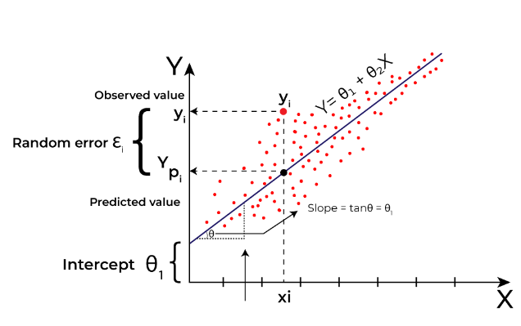Figure 1 Linear Regression

Figure 1: For forecasting continuous numerical values, one of the most basic regression models is linear regression. It uses the equation y=mx+cy = mx + cy=mx+c to fit a straight line and create a link between independent variables and a dependent variable. This model is interpretable and effective for datasets with linear patterns since it assumes a linear connection between characteristics and the target variable. However, it has trouble handling intricate, non-linear connections, and when it comes to high-dimensional data, it tends to underfit .

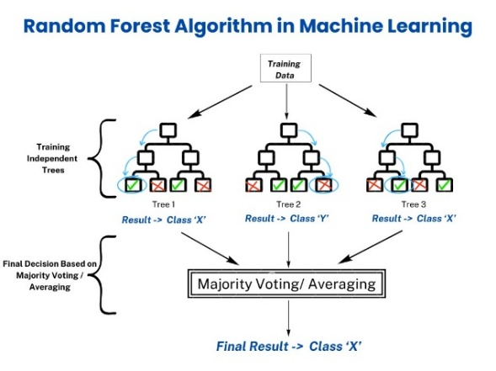

Figure 2 Random Forest

Random Forest builds several decision trees and aggregates their results to increase prediction accuracy. In contrast to single decision trees, it reduces overfitting by randomly choosing subsets of data and characteristics for each tree . The model can handle both classification and regression tasks, is noise-resistant, and works well on big datasets. To get the best results, it may be necessary to adjust hyperparameters like the number of trees, which might be computationally costly.

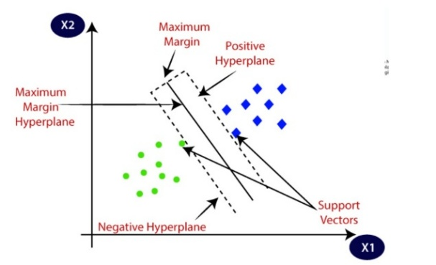

Figure 3 GBM

Another ensemble approach that develops models in a sequential fashion is GBM, in which each new model fixes mistakes caused by earlier models . By reducing mistakes, GBM repeatedly improves performance through boosting, in contrast to Random Forest, which grows trees individually. Although it requires a lot of computing, it works very well with organized data and achieves great accuracy . If not regularized appropriately, it may also be prone to overfitting, which is why careful parameter tweaking is essential.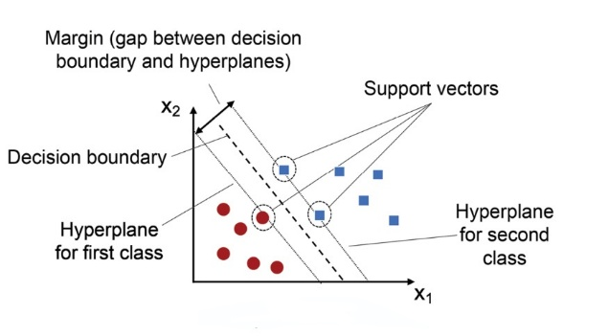

Figure 4 SVM

SVM is a potent regression and classification model that determines the best hyperplane for classifying data points . When there is a complicated and non-linear relationship between variables, it is especially helpful in high-dimensional spaces . The model may convert data into higher dimensions for improved separation by using a variety of kernel functions, including linear, polynomial, and radial basis functions. SVM may be sluggish on big datasets despite its high performance, and the optimal kernel parameters must be carefully chosen.

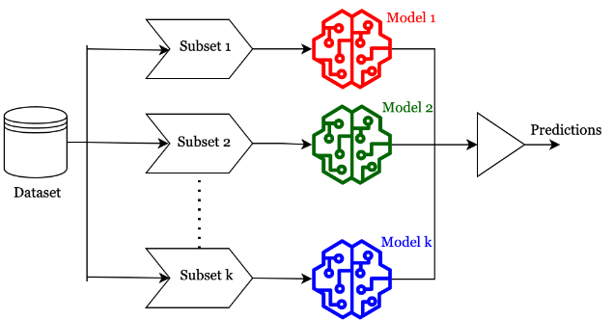

Figure 5 Ensemble Learning

Ensemble learning is a machine learning approach that uses many models to increase prediction performance, accuracy, and generalization . Instead of depending on a single model, ensemble approaches combine predictions from numerous models to decrease errors, improve resilience, and prevent overfitting.

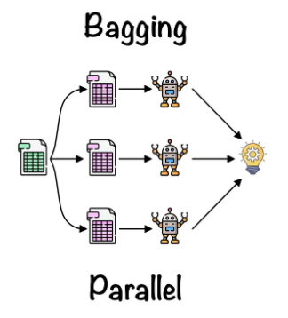

Figure 6 Bagging

Machine learning models' variance may be decreased by using the ensemble learning approach known as bagging. It uses several bootstrapped datasets to train many models separately. Randomly collected data with replacement is used to train each model. Either majority vote for categorization or averaging regression findings yields the final forecast. One wel known bagging algorithm is Random Forest .

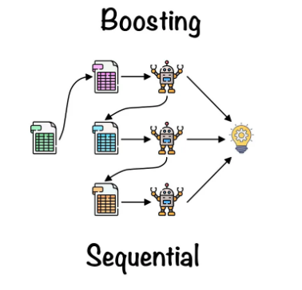

Figure 7 Boosting

Figure 7:Another ensemble method that lessens bias is boosting, which trains weak models one after the other . By assigning larger weights to examples that were incorrectly categorized, each new model aims to fix earlier errors . The weighted total of all the models is the final forecast. To increase model accuracy, algorithms such as AdaBoost, Gradient Boosting, and XGBoost are frequently employed.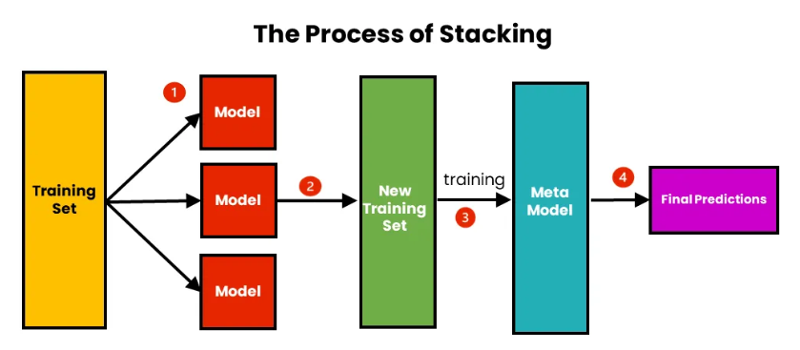

Figure 8 Stacking

Figure 8:Stacking is an ensemble learning strategy that uses many models to increase accuracy. Different base models yield predictions, which are then fed into a meta-model to get the final forecast. It maximizes model variety, decreases biases, and improves performance, but it is computationally difficult and necessitates careful model selection .

**5.System Flow Diagram**

By combining structured medical datasets from Kaggle with real-time wearable data, we aim to improve forecasting of menstruation onset and fertile windows, particularly for individuals with irregular cycles .

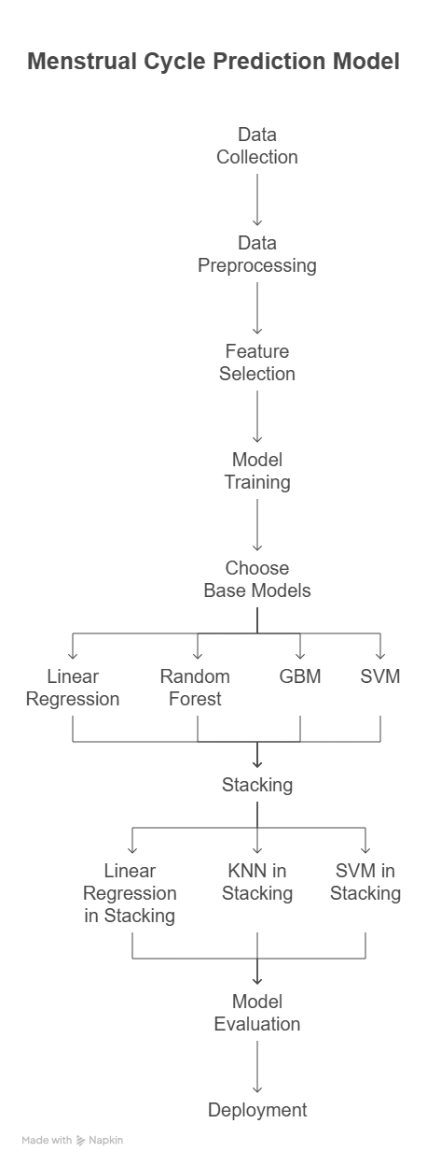

Figure 9 System Flow Diagram

Figure 9:The Menstrual Cycle Prediction Model starts with data gathering, in which appropriate information like previous cycle dates, symptoms, hormone levels, and lifestyle variables are obtained. The prediction accuracy relies on the quality and completeness of the data, and thus this step is very important.

After the data is accumulated, data pre-processing occurs. Data cleaning involves dealing with missing values, normalizing numerical values, encoding categories, and discarding inconsistencies. There should be accurate pre-processing so that the dataset is organized and ready to be used by machine learning algorithms.

Following pre-processing, the feature selection procedure is carried out to determine which variables have a significant impact on the menstrual cycle. Choosing all the most valuable features improves the performance of models and minimizes computational complexity through the removal of irrelevant or duplicate data.

With the improved dataset, the training of the model starts. Various machine learning algorithms are trained to learn patterns from the data so that they can make correct predictions regarding the menstrual cycle. Training the models enables them to understand the relationships between input features and cycle predictions.

In the second stage, base models are selected to make predictions. Some machine learning models like Linear Regression, Random Forest, Gradient Boosting Machine (GBM), and Support Vector Machine (SVM) are selected. Each of these models makes prediction individually with strength in processing data patterns of varying types.

To add precision, stacking (ensemble learning) is applied, whereby predictions from various base models are merged by a meta-model. Various stacking methods such as Linear Regression in Stacking, K-Nearest Neighbors (KNN) in Stacking, and SVM in Stacking assist in refining the final output by making use of the strengths of several models.

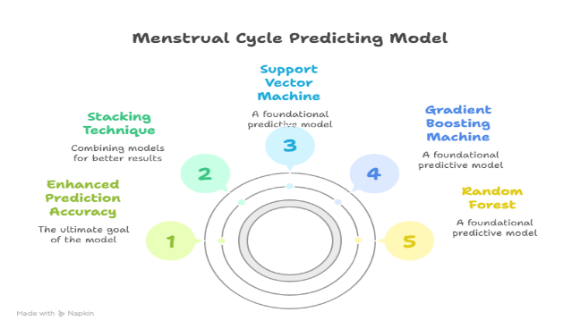

Figure 10 Architecture Diagram

Figure 10 : Menstrual Cycle Prediction Model is a methodical process applying various machine learning models to arrive at a highly accurate prediction. It utilizes Stacking Technique, Improved Prediction Accuracy, Support Vector Machine (SVM), Gradient Boosting Machine (GBM), and Random Forest.

The Stacking Technique uses various base models together with their strengths towards a solid overall prediction. The ultimate objective is Improved Prediction Accuracy, making predictions as accurate as possible for forecasting menstrual cycles.

SVM discovers cycle patterns through margin-based classification. GBM enhances predictions by adjusting mistakes iteratively, and Random Forest minimizes overfitting through multiple decision trees.

The stacked model enhances predictions through a meta-model, resulting in more accurate results. This approach addresses key challenges in existing studies by providing more personalized and accurate predictions. The dataset was refined by handling missing values, standardizing numerical features, and encoding categorical variables. This ensured data consistency and improved model performance. The data was then split into training and testing sets to prevent overfitting and enable accurate evaluation .

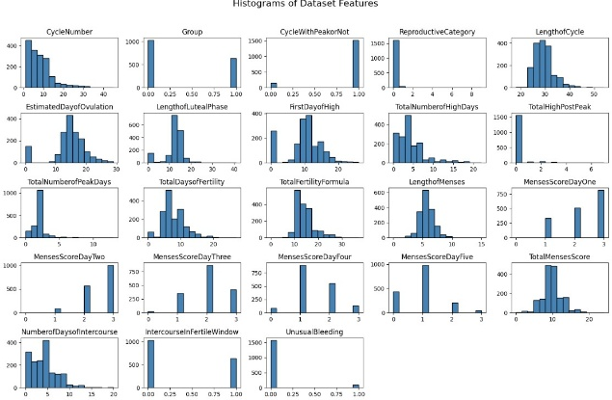

Figure 11 Histogram Features

Figure 10: The diagram displays histograms of dataset features related to menstrual health, such as cycle length, reproductive category, and various hormonal levels. Each histogram shows the distribution of a feature, revealing skewness, peaks, and variability. Some features have normal distributions, while others exhibit skewed or categorical patterns, indicating data diversity.

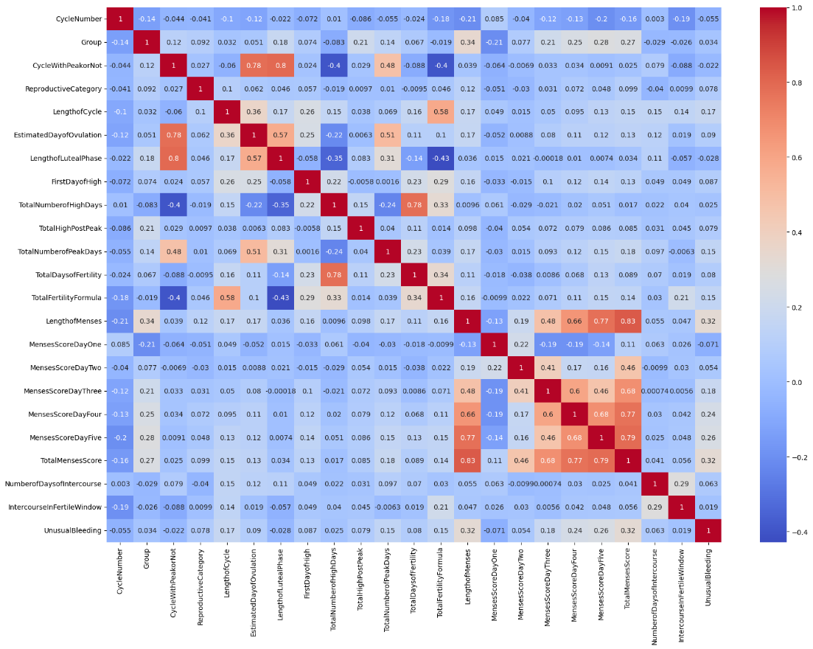

Figure 12 Correlation Matrix Heat map.

Figure 11: The correlation matrix heatmap depicts the correlations between numerical features using Pearson correlation coefficients (from -1 to +1) [9]. Red regions represent significant positive connections, blue areas show negative correlations, and lighter tones denote weaker links. The diagonal values are always 1, indicating that each characteristic is completely associated with itself. Cycle length, hormones, and lifestyle variables can all have an impact on features like "Length of Menses" [14]. Strongly correlated features (red clusters) may suggest redundancy, necessitating feature selection to prevent multicollinearity. Understanding these associations allows us to enhance predictive models and obtain insight into menstrual health concerns [19]

We used Linear Regression as a baseline, Random Forest for improved accuracy, GBM for error reduction, and SVM for handling complex patterns in menstrual cycle prediction [10].

In order to improve prediction accuracy, stacking entails putting into practice and assessing an ensemble model that combines Support Vector Machine (SVM) and Linear Regression [15]. This method uses the predictions of both models, which are trained separately, as input features for a meta-learner, usually another Linear Regression model. By utilizing the advantages of both base models, the meta-learner improves overall performance by analysing these predictions to produce the final result [18]. The efficacy of the stacked ensemble model is assessed by measuring performance utilizing important assessment measures [22].

**6.Experimental Results**

Table 1 comparisons between different models

|  |  |  |  |  |  |
| --- | --- | --- | --- | --- | --- |
| **Model** | **MSE** | **RMSE** | **MAE** | **MAPE%** | **R2**  **Score** |
| SVM | 4.9284 | 2.2201 | 1.1069 | 3.7 | |  | | --- | | 0.6462 | |
| Gradient Boosting | |  | | --- | |  |   1.8509 | 1.3605 | 0.6025 | 2.04 | 0.8671 |
| Random Forest | 1.7989 | 1.3412 | 0.515 | 1.71 | 0.8709 |
| Linear Regression | 3.8095 | 1.9501 | 1.0098 | 3.4 | 0.7269 |

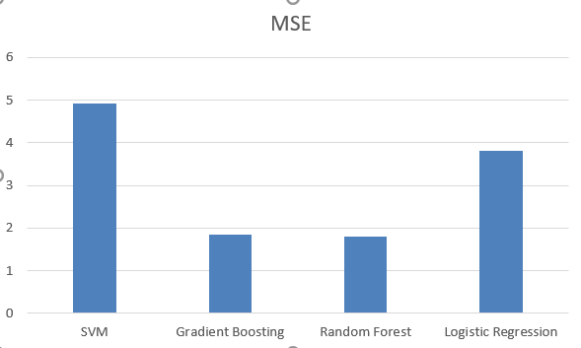

Figure 13 MSE value comparison

Figure 13: The four machine learning models, SVM, Random Forest, Gradient Boosting, and Linear Regression, are compared on the basis of their Mean Squared Error (MSE) in the bar chart. Although Random Forest and Gradient Boosting are slightly better with fewer errors, SVM is the model with the highest MSE, and then comes Linear Regression.

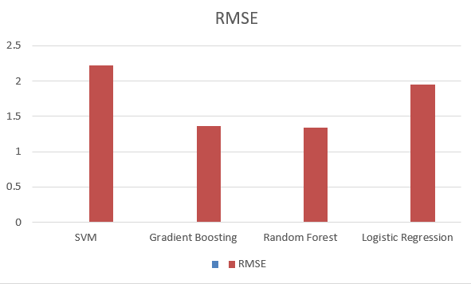

Figure 14 RMSE value comparison

Figure 14: Bar chart shows comparison of RMSE of all four models such as SVM, Random Forest, Gradient Boosting, and Linear Regression. Lesser errors and better performance are performed by Random Forest and Gradient Boosting and greatest RMSE depicted by SVM and then by that of Linear Regression.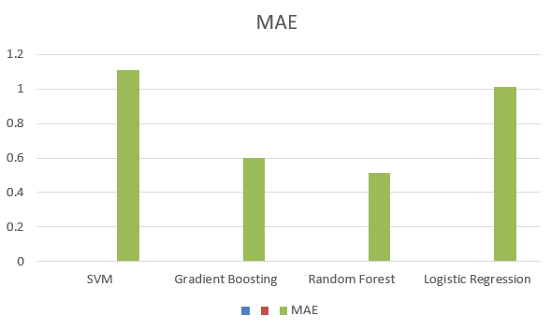

Figure 15 MAE value comparison

Figure 15: Bar chart is used to compare the Root Mean Squared Error (RMSE) of four models, i.e., SVM, Random Forest, Gradient Boosting, and Linear Regression. SVM has the highest RMSE, and then comes Linear Regression, but Random Forest and Gradient Boostingare superior and commit less error. A graph with blue bars

Figure 16 MAPE value comparison

Figure 16: The bar plot demonstrates the Mean Absolute Percentage Error (MAPE) of four models, namely Linear Regression, SVM, Random Forest, and Gradient Boosting. Both Linear Regression and SVM possess the highest MAPE, whereas Random Forest and Gradient Boosting have smaller errors, which reflect better performance.

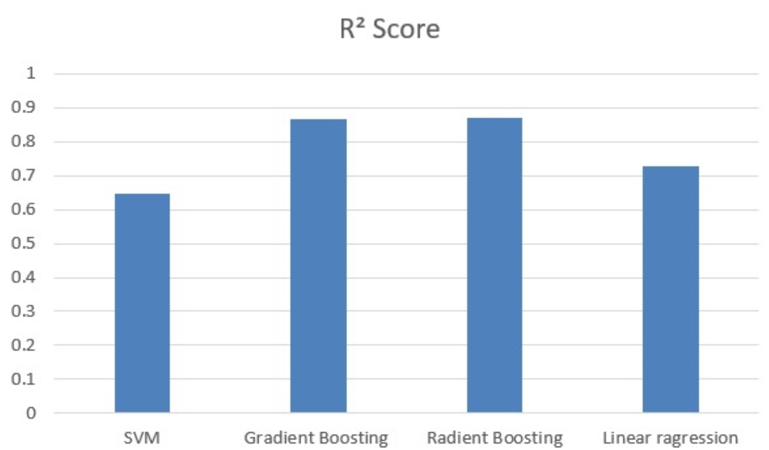

Figure 17 R² Score value comparison

Figure 17: The graph shows the comparison of R² scores for various machine learning algorithms: SVM, Gradient Boosting, Random Forest, and Linear Regression. Random Forest and Gradient Boosting produce the highest scores, followed by Linear Regression, while SVM provides the lowest among them.

Table 2 Stacking

|  |  |
| --- | --- |
| R2 Score | 0.79206 |
| MSE | 2.89657 |
| RMSE | 1.70193 |
| MAE | 1.01981 |
| MAPE | 3.44% |

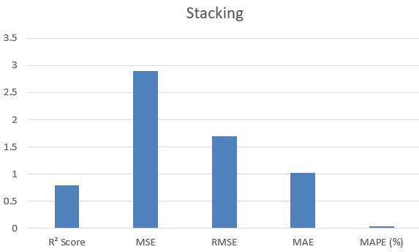

Figure 18 Stacking

Figure 18: The chart illustrates the performance metrics of a stacking model, i.e., R² Score, MSE, RMSE, MAE, and MAPE (%). MSE is the highest, followed by RMSE and then MAE, and R² Score is comparatively low, which reflects possible improvement space in terms of prediction accuracy.

**7.Conclusion**

This study illustrates the use of machine learning models in forecasting the menstrual cycle and its stages. Among the models tested, ensemble techniques like Random Forest and Gradient Boosting Machine (GBM) beat conventional approaches in terms of accuracy and pattern recognition. While the Support Vector Machine (SVM) handled nonlinearity well, it had scalability concerns, and Linear Regression, while interpretable, lacked predictive strength. The models' dependability was proven by a rigorous review utilizing measures such as MSE, RMSE, MAE, MAPE, and R² Score. Predictions were consistent with recognized medical research. While stacking using Linear Regression, SVM, and KNN was investigated, standalone models such as SVM and GBM shown greater performance.

Future enhancements may include hyper parameter tweaking, deep learning approaches (ANN, CNN), enhanced feature selection (PCA, LDA), data imbalance management (SMOTE), and real-world deployment via Flask or FastAPI. These developments can improve the accuracy, efficiency, and usability of menstrual health tracking systems.

**References**

1. Bull JR, Rowland SP, Scherwitzl EB, Scherwitzl R, Danielsson KG, Harper J. Real-world menstrual cycle characteristics of more than 600,000 menstrual cycles. NPJ Digit Med 2019;2(1):83
2. Zhang Q, Wang Y, Zhang Y, Zhang H, Yang Y, He Y, et al. The influence of age at menarche, menstrual cycle length and bleeding duration on time to pregnancy: a large prospective cohort study among rural Chinese women. BJOG 2017 Oct;124(11):1654-1662
3. Wei S, Schmidt M, Dwyer T, Norman R, Venn A. Obesity and menstrual irregularity: associations with SHBG, testosterone, and insulin. Obesity (Silver Spring) 2009 May;17(5):1070-1076
4. Baird DD, McConnaughey DR, Weinberg CR, Musey PL, Collins DC, Kesner JS, et al. Application of a method for estimating day of ovulation using urinary estrogen and progesterone metabolites. Epidemiology 1995 Sep;6(5):547-550.
5. Treloar AE, Boynton RE, Behn BG, Brown BW. Variation of the human menstrual cycle through reproductive life. Int J Fertil 1967;12(1 Pt 2):77-126.
6. Lenton EA, Landgren BM, Sexton L, Harper R. Normal variation in the length of the follicular phase of the menstrual cycle: effect of chronological age. Br J Obstet Gynaecol 1984 Jul;91(7):681-684.
7. Münster K, Schmidt L, Helm P. Length and variation in the menstrual cycle-a cross-sectional study from a Danish county. Br J Obstet Gynaecol 1992
8. Liu Y, Gold EB, Lasley BL, Johnson WO. Factors affecting menstrual cycle characteristics. Am J Epidemiol 2004 Jul 15;160(2):131-140.
9. Ansong E, Arhin SK, Cai Y, Xu X, Wu X. Menstrual characteristics, disorders and associated risk factors among female international students in Zhejiang Province, China: a cross-sectional survey. BMC Womens Health 2019 Feb 18;19(1):35
10. Nillni Y, Wesselink A, Hatch E, Mikkelsen E, Gradus JL, Rothman KJ, et al. Mental health, psychotropic medication use, and menstrual cycle characteristics. Clin Epidemiol 2018;10:1073-1082
11. Schliep KC, Mumford SL, Vladuti CJ, Ahrens KA, Perkins NJ, Sjaarda LA, et al. Perceived stress, reproductive hormones, and ovulatory function: a prospective cohort study. Epidemiology 2015 Mar;26(2):177-184
12. Vannuccini S, Fondelli F, Clemenza S, Galanti G, Petraglia F. Dysmenorrhea and heavy menstrual bleeding in elite female athletes: quality of life and perceived stress. Reprod Sci 2020 Mar;27(3):888-894.
13. Harlow S, Matanoski G. The association between weight, physical activity, and stress and variation in the length of the menstrual cycle. Am J Epidemiol 1991 Jan;133(1):38-49.
14. Hartz AJ, Barboriak PN, Wong A, Katayama KP, Rimm AA. The association of obesity with infertility and related menstural abnormalities in women. Int J Obes 1979;3(1):57-73.
15. Rogers J, Mitchell GW. The relation of obesity to menstrual disturbances. N Engl J Med 1952 Jul 10;247(2):53-55.
16. Ng M, Fleming T, Robinson M, Thomson B, Graetz N, Margono C, et al. Global, regional, and national prevalence of overweight and obesity in children and adults during 1980-2013: a systematic analysis for the global burden of disease study 2013. Lancet 2014 Aug 30;384(9945):766-781 .
17. Freis A, Freundl-Schütt T, Wallwiener L, Baur S, Strowitzki T, Freundl G, et al. Plausibility of menstrual cycle apps claiming to support conception. Front Public Health 2018;6:98
18. Jennings V, Haile LT, Simmons RG, Spieler J, Shattuck D. Perfect- and typical-use effectiveness of the Dot fertility app over 13 cycles: results from a prospective contraceptive effectiveness trial. Eur J Contracept Reprod Health Care 2019 Apr;24(2):148-153.
19. Lupton D. Quantified sex: a critical analysis of sexual and reproductive self-tracking using apps. Cult Health Sex 2015;17(4):440-453.
20. Starling MS, Kandel Z, Haile L, Simmons RG. User profile and preferences in fertility apps for preventing pregnancy: an exploratory pilot study. Mhealth 2018
21. Symul L, Wac K, Hillard P, Salathé M. Assessment of menstrual health status and evolution through mobile apps for fertility awareness. NPJ Digit Med 2019
22. Johnson S, Marriott L, Zinaman M. Can apps and calendar methods predict ovulation with accuracy? Curr Med Res Opin 2018 Sep
23. Bradley D, Landau E, Jesani N, Mowry B, Chui K, Baron A, et al. Time to conception and the menstrual cycle: an observational study of fertility app users who conceived. Hum Fertil (Camb) 2019 May 16
24. Faust L, Bradley D, Landau E, Noddin K, Farland LV, Baron A, et al. Findings from a mobile application-based cohort are consistent with established knowledge of the menstrual cycle, fertile window, and conception. Fertil Steril 2019 Sep;112(3
25. Hughson JP, Daly JO, Woodward-Kron R, Hajek J, Story D. The rise of pregnancy apps and the implications for culturally and linguistically diverse women: narrative review. JMIR Mhealth Uhealth 2018 Nov 16.
26. Arévalo M, Jennings V, Sinai I. Efficacy of a new method of family planning: the standard days method. Contraception 2002 May.
27. Norman RJ, Clark AM. Obesity and reproductive disorders: a review. Reprod Fertil Dev 1998.
28. Leeners B, Geary N, Tobler P, Asarian L. Ovarian hormones and obesity. Hum Reprod Update 2017 May 1.
29. Inoue Y, Qin B, Poti J, Sokol R, Gordon-Larsen P. Epidemiology of obesity in adults: latest trends. Curr Obes Rep 2018 Dec.
30. Constantini NW, Dubnov G, Lebrun CM. The menstrual cycle and sport performance. Clin Sports Med 2005 Apr;24(2):e51-82, xiii. .
31. Czajkowska M, Plinta R, Rutkowska M, Brzęk A, Skrzypulec-Plinta V, Drosdzol-Cop A. Menstrual cycle disorders in professional female rhythmic gymnasts. Int J Environ Res Public Health 2019 Apr 25.
32. Meczekalski B, Katulski K, Czyzyk A, Podfigurna-Stopa A, Maciejewska-Jeske M. Functional hypothalamic amenorrhea and its influence on women's health. J Endocrinol Invest 2014 Nov;37(11):1049-1056.
33. Sternfeld B, Jacobs M, Quesenberry CJ, Gold E, Sowers M. Physical activity and menstrual cycle characteristics in two prospective cohorts. Am J Epidemiol 2002 Sep 1;156(5):402-409.
34. Hahn K, Wise L, Riis AH, Mikkelsen EM, Rothman KJ, Banholzer K, et al. Correlates of menstrual cycle characteristics among nulliparous Danish women. Clin Epidemiol 2013;5:311-319
35. Yamamoto K, Okazaki A, Sakamoto Y, Funatsu M. The relationship between premenstrual symptoms, menstrual pain, irregular menstrual cycles, and psychosocial stress among Japanese college students. J Physiol Anthropol 2009;28(3):129-136.

,